**Aim: Layer 2 VLAN Security.**

**Part 1: Configure Switch/Router**:

1. **Step 1: Configure secret**

Execute command on all switches/router

SW/R1(config)# **enable secret enpa55**

1. **Step 2: Configure console password**

Execute command on all switches/router

SW/R1(config)# **line console 0**

SW/R1(config-line)# **password conpa55**

SW/R1(config-line)# **login**

1. **Step 3: Configure SSH login**

Execute command on all switches/router

SW/R1(config)# **ip domain-name ccnasecurity.com**

SW/R1(config)# **username admin secret adminpa55**

SW/R1(config)# **line vty 0 4**

SW/R1(config-line)# **login local**

SW/R1(config-line)# **crypto key generate rsa**

**Part 2: Create VLAN and assign access mode and trunk mode to interfaces:**

1. **Step 1: Check existing VLAN**

Execute command on all switches

SW# **show vlan brief**

1. **Step 2: Create new VLAN**

Execute command on all switches

SW(config)# **vlan 5**

SW(config-vlan) # **exit**

SW(config)# **vlan 10**

SW(config-vlan) # **exit**

SW(config)# **vlan 15**

SW(config-vlan) # **exit**

1. **Step 3: Check the new**

VLAN Execute command on all switches

SW# **show vlan brief**

1. **Step 4: Assign access mode to VLAN switch interfaces**

Execute command on switches SWA/SWB

SWA(config)# **int fa0/2**

SWA(config -if)# **switchport mode access**

SWA(config -if)# **switchport access vlan 10**

SWA(config)# **int fa0/3**

SWA(config -if)# **switchport mode access**

SWA(config -if)# **switchport access vlan 10**

SWA(config)# **int fa0/4**

SWA(config -if)# **switchport mode access**

SWA(config -if)# **switchport access vlan 5**

SWB(config)# **int fa0/1**

SWB(config -if)# **switchport mode access**

SWB(config -if)# **switchport access vlan 5**

SWB(config)# **int fa0/2**

SWB(config -if)# **switchport mode access**

SWB(config -if)# **switchport access vlan 5**

SWB(config)# **int fa0/3**

SWB(config -if)# **switchport mode access**

SWB(config -if)# **switchport access vlan 5**

SWB(config)# **int fa0/4**

SWB(config -if)# **switchport mode access**

SWB(config -if)# **switchport access vlan 10**

1. **Step 5: Check the access mode allocations**

SWA# **show vlan brief**

SWB# **show vlan brief**

1. **Step 6: Assign trunk mode to other switch interfaces**

SWA(config)# **int fa0/24**

SWA(config -if)# **switchport mode trunk**

SWA(config -if)# **switchport trunk native vlan 15**

SWB(config)# **int fa0/24**

SWB(config -if)# **switchport mode trunk**

SWB(config -if)# **switchport trunk native vlan 15**

SW1(config)# **int fa0/24**

SW1(config -if)# **switchport mode trunk**

SW1(config -if)# **switchport trunk native vlan 15**

SW1(config)# **int gig0/1**

SW1(config -if)# **switchport mode trunk**

SW1(config -if)# **switchport trunk native vlan 15**

SW2(config)# **int fa0/24**

SW2(config -if)# **switchport mode trunk**

SW2(config -if)# **switchport trunk native vlan 15**

SW2(config)# **int gig0/1**

SW2(config -if)# **switchport mode trunk**

SW2(config -if)# **switchport trunk native vlan 15**

Central(config)# **int range gig0/1-2**

Central (config –if-range)# **switchport mode trunk**

Central(config –if-range)# **switchport trunk native vlan 15**

Central(config)# **int fa0/1**

Central(config –if)# **switchport mode trunk**

Central(config –if)# **switchport trunk native vlan 15**

1. **Step 7: Check the trunk mode** **allocations**

Central# **show int trunk**

SW1/2# **show int trunk**

SWA/B# **show int trunk**

1. **Step 8: Create sub-interfaces on router to support VLAN**

R1(config)# **int gig0/0.1**

R1(config - subif)# **encapsulation dot1q 5**

R1(config - subif)# **ip address 192.168.5.100 255.255.255.0**

R1(config)# **int gig0/0.2**

R1(config - subif)# **encapsulation dot1q 10**

R1(config - subif)# **ip address 192.168.10.100 255.255.255.0**

R1(config)# **int gig0/0.15**

R1(config - subif)# **encapsulation dot1q 15**

R1(config - subif)# **ip address 192.168.15.100 255.255.255.0**

**Part 3: Verify Connectivity:**

1. **Step 1: Verify connectivity between C2 (VLAN 10) and C3 (VLAN 10).**

C2> **ping 192.168.10.2** (Successful)

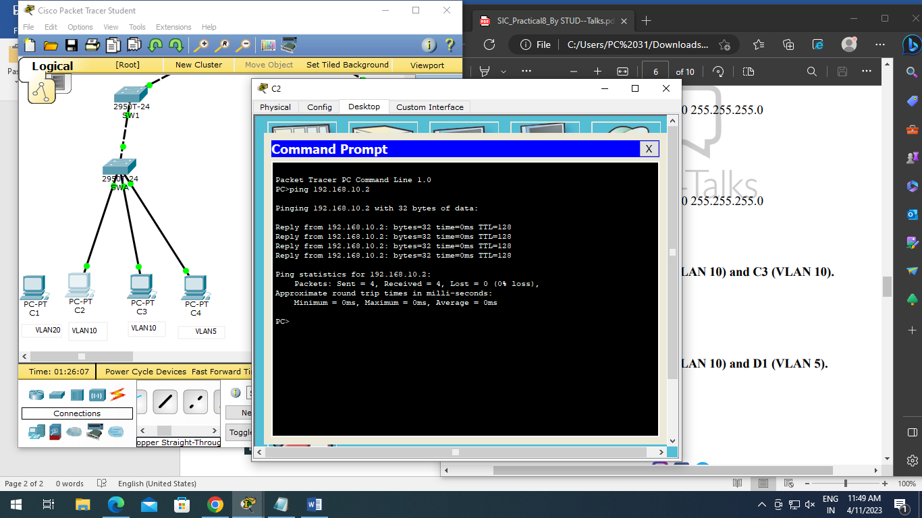

1. **Step 2: Verify connectivity between C2 (VLAN 10) and D1 (VLAN 5).**

PC2> **ping 192.168.5.2** (Successful)

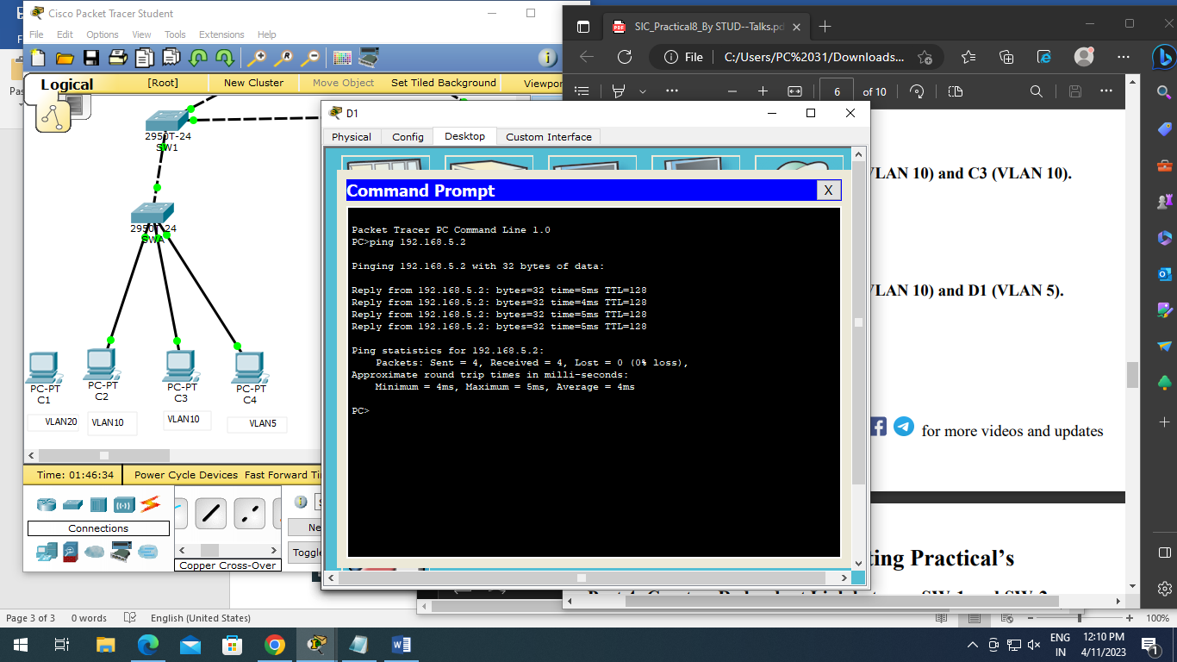

**Part 4: Create a Redundant Link between SW-1 and SW-2:**

1. **Step 1: Connect SW-1 and SW-2.**

Using a crossover cable, connect port Fa0/23 on SW-1 to port Fa0/23 on SW-2.

1. **Step 2: Enable trunking, including all trunk security mechanisms on the link between SW-1 and SW-2**.

(Execute command on SW- 1 and SW-2)

SW1/2(config)# **int fa0/23**

SW1/2(config-if)# **switchport mode trunk**

SW1/2(config-if)# **switchport trunk native vlan 15**

SW1/2(config-if)# **switchport nonegotiate**

**Part 5: Enable VLAN 20 as a Management VLAN**:

1. **Step 1: Enable a management VLAN (VLAN 20) on SW-A**.

SW-A(config)# **vlan 20**

SW-A(config-vlan)# **exit**

SW-A(config)# **int vlan 20**

SW-A(config-if)# **ip address 192.168.20.1 255.255.255.0**

1. **Step 2: Enable the same management VLAN on all other switches**

(Execute command on SW-B, SW-1, SW-2, and Central)

SW(config)# **vlan 20**

SW(config-vlan)# **exit**

1. Create an interface VLAN 20 on all switches and assign an IP address within the 192.168.20.0/24 network.

SW-B(config)# **int vlan 20**

SW-B(config-if)# **ip address 192.168.20.2 255.255.255.0**

SW-1(config)#**int vlan 20**

SW-1(config-if)#**ip address 192.168.20.3 255.255.255.0**

SW-2(config)#**int vlan 20**

SW-2(config-if)#**ip address 192.168.20.4 255.255.255.0**

Central(config)# **int vlan 20**

Central(config-if)# **ip address 192.168.20.5 255.255.255.0**

1. **Step 3: Connect and configure the management PC.**

Connect the management PC using copper straight-through to SW-A port Fa0/1 and ensure that it is assigned an available IP address 192.168.20.50

1. **Step 4: On SW-A, ensure the management PC is part of VLAN 20.**

SW-A(config)# **int fa0/1**

SW-A(config)# **switchport mode access**

SW-A(config-if)# **switchport access vlan 20**

1. **Step 5: Verify connectivity of the management PC to all switches**.
2. C1> **ping 192.168.20.1** (SW-A) (Successful)

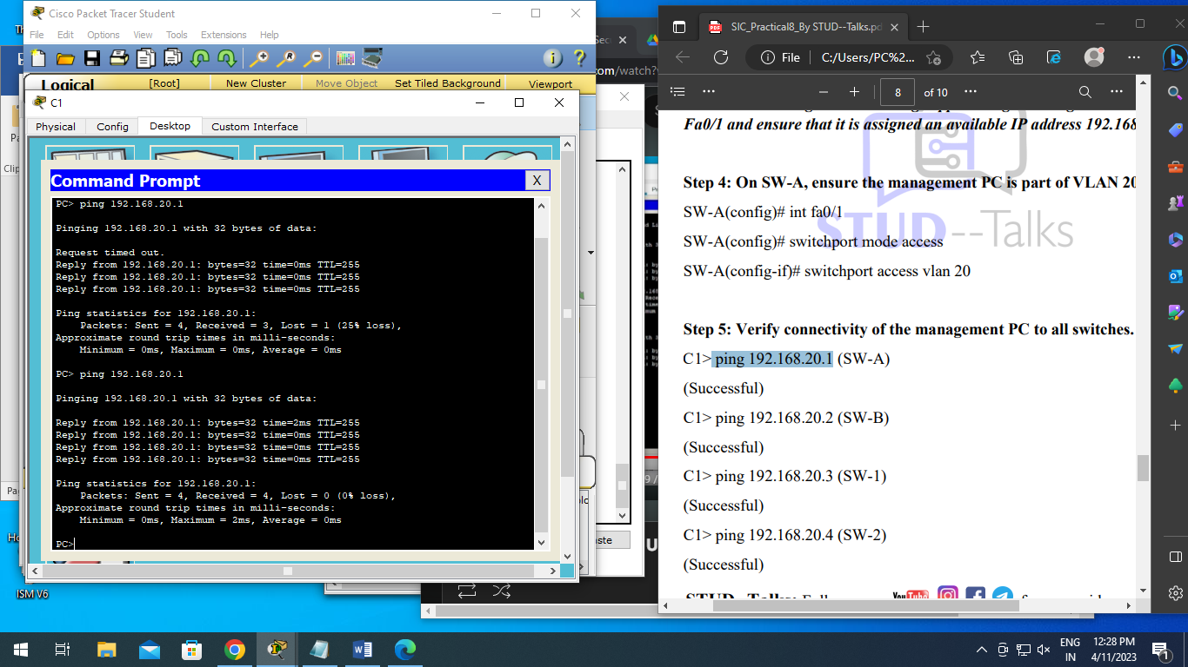

1. C1> **ping 192.168.20.2** (SW-B) (Successful)

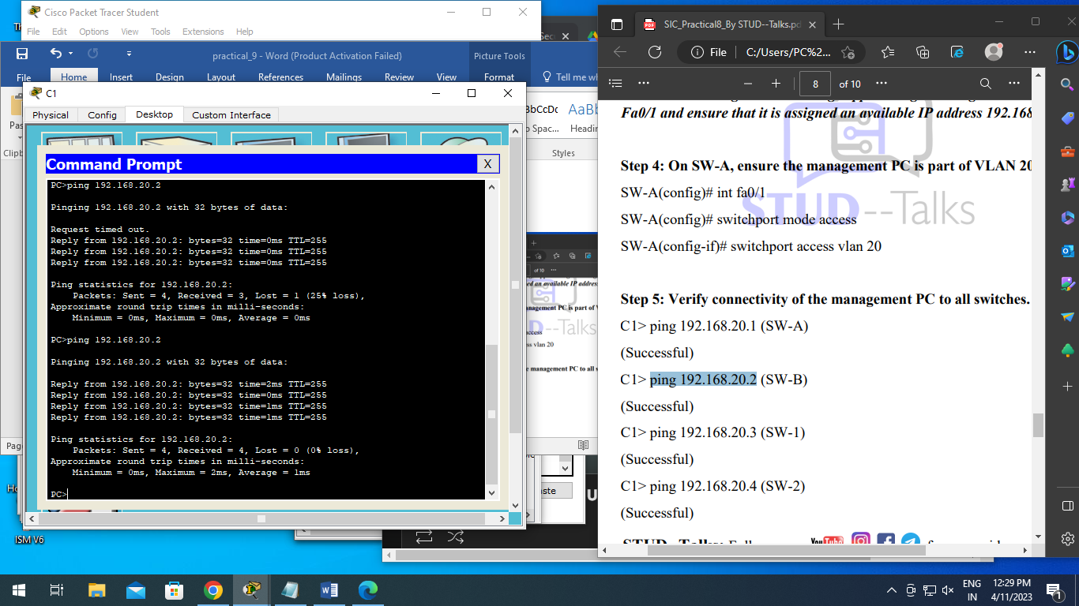

1. C1> **ping 192.168.20.3** (SW-1) (Successful)

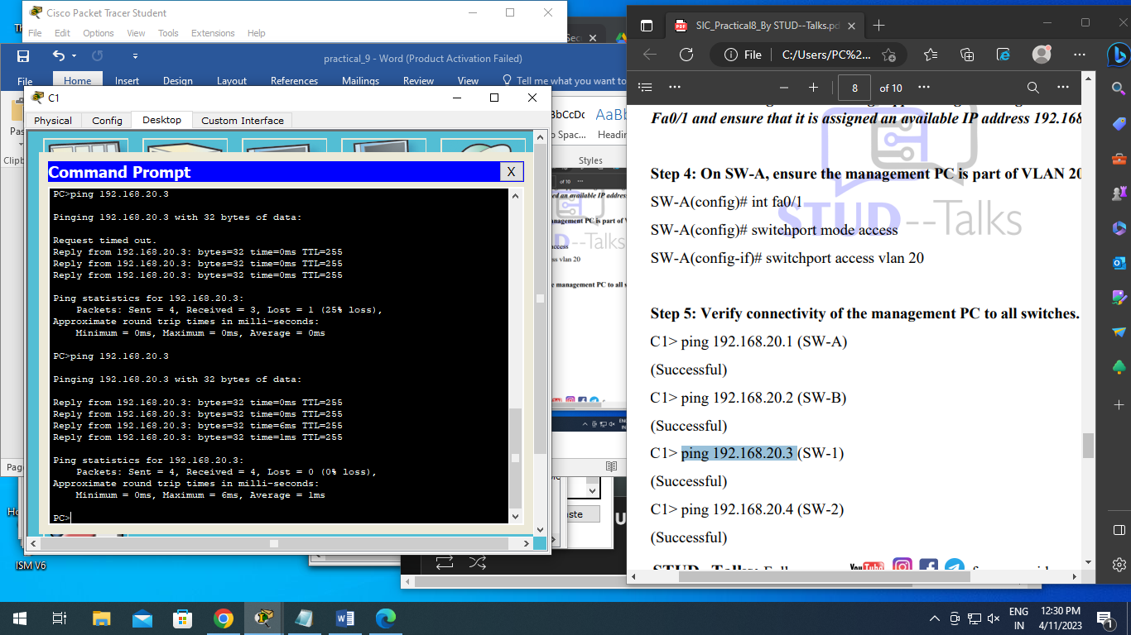

1. C1> **ping 192.168.20.4** (SW-2) (Successful)

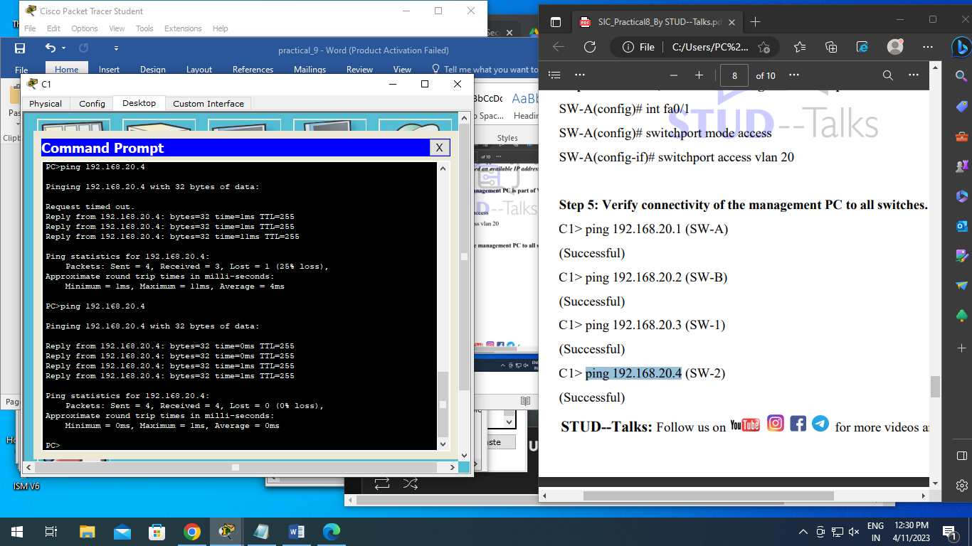

1. C1> ping 192.168.20.5 (Central) (Successful)

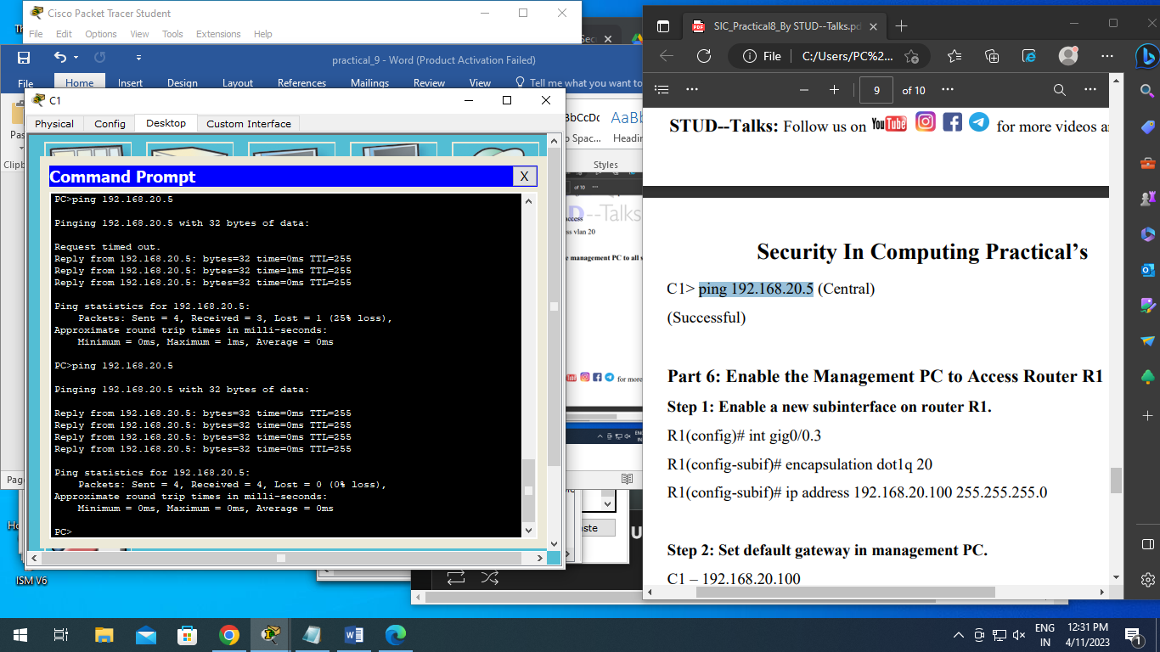

**Part 6: Enable the Management PC to Access Router R1**:

1. **Step 1: Enable a new subinterface on router R1.**

R1(config)# int gig0/0.

R1(config-subif)# encapsulation dot1q 20

R1(config-subif)# ip address 192.168.20.100 255.255.255.0

1. **Step 2: Set default gateway in management PC**.

C1 – 192.168.20.100

1. **Step 3: Verify connectivity between the management PC and R1.**

C1> ping 192.168.20.100 (Successful)

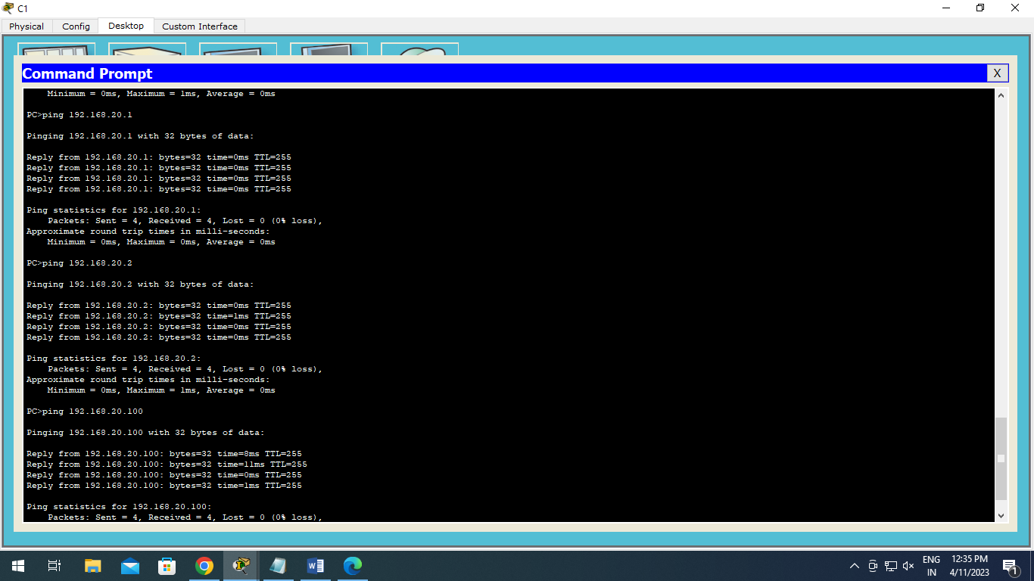

1. **Step 4: Enable security**.

R1(config)# access-list 101 deny ip any 192.168.20.0 0.0.0.255

R1(config)# access-list 101 permit ip any any

R1(config)# access-list 102 permit ip host 192.168.20.50 any

1. **Step 5: Apply ACL on correct interfaces**

R1(config)# int gig0/0.1

R1(config-subif)# ip access-group 101 in

R1(config-subif)# int gig0/0.2

R1(config-subif)# ip access-group 101 in

R1(config-subif)# line vty 0 4

R1(config-line)# access-class 102 in

1. **Step 6: Verify connectivity between the management PC and SW-A, SW-B and R1**

C1> ping 192.168.20.1 (SW-A) (Successful)

C1> ping 192.168.20.2 (SW-B) (Successful)

C1> ping 192.168.20.100 (R1) (Successful)

1. **Step 7: Verify connectivity between the D1 and management PC**.

D1>ping 192.168.20.50 (Unsuccessful – Destination host unreachable

**Output:**

